# Experiment No 2

<html>

<head>

<style>

fieldset {

background-color: yellow;

}

</style>

</head>

<body>

<form>

<fieldset style="width:100px;">

<legend>Student Details</legend>

<table>

<tr>

<td>UserName</td>

<td><input type="text" id="one"></td>

</tr>

<tr>

<td>Password</td>

<td><input type="password" id="three"></td>

</tr>

<tr>

<td>Age</td>

<td><input type="number" id="two"></td>

</tr>

<tr>

<td>DOB</td>

<td><input type="date" id="birthday" name="birthday"></td>

</tr>

<tr>

<td> Gender </td>

</td>

<td colspan="2">

Male:<input type="radio" id="gen" name="Gender" value="male">

Female:<input type="radio" id="gen" name="Gender" value="female"> </td>

</tr>

<tr>

<td> Email Id</td>

<td><input type="email" id="email" name="email"></td>

</tr>

<tr>

<td>Branch</td>

<td>

<select>

<option selected>CSE</option>

<option>ENTC</option>

<option>MECH</option>

<option>CIVIL</option>

</select>

</td>

</tr>

<tr>

<td> Comment </td>

<td><textarea width="600"></textarea></td>

</tr>

<tr>

<td> </td>

<td> <input type="button" id="four" value="submit"> </td>

</tr>

</table>

</fieldset>

</form>

</body>

</html>

**Output :**

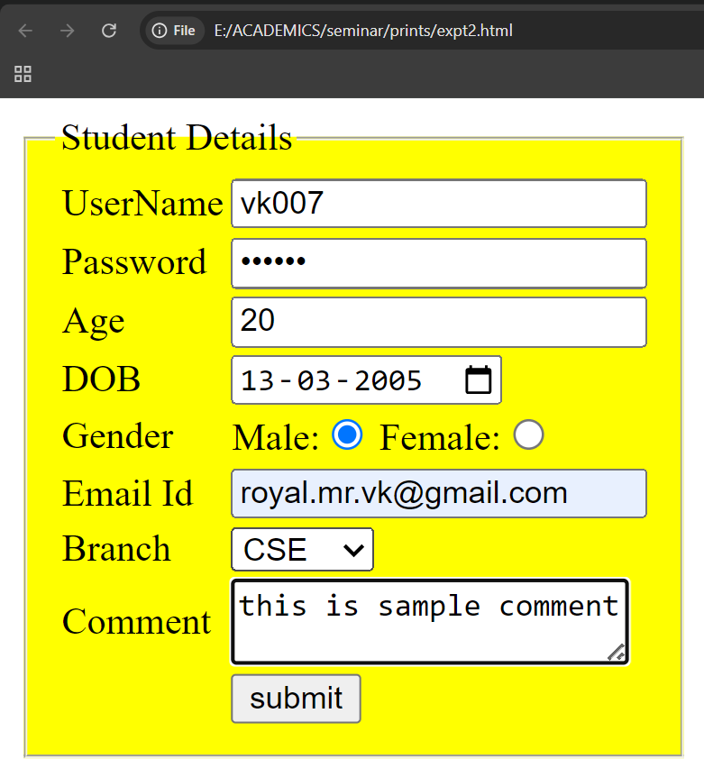

**Experiment No 3**

<html><head>

<link rel="stylesheet" href="https://cdnjs.cloudflare.com/ajax/libs/font-awesome/4.7.0/css/font-awesome.min.css">

<style>

input[type=text] { width: 200px; }

li { display: inline; padding: 10px; font-size: 25px; }

header { background-color: green; padding: 10px; }

nav li a:hover { background-color: red; border-radius: 5px; }

nav li a { text-decoration: none; }

.sticky { position: fixed; top: 0; width: 100%; }

.a, .aboutus, p { text-align: justify; }

.a { display: flex; margin: 400px 0; padding-right: 20px; font-family: "Times New Roman", Times, serif; }

#b { background-color: red; padding: 20px; font-size: 20px; }

#k, #cse { margin-top: 400px; }

</style></head>

<body>

<header class="sticky">

<nav> <ul>

<li><img src="" style="height:50px;width:50px;"></li>

<li style="color:red;">Karmayogi Institute Of Technology</li>

<li><a href="#home">home</a></li>

<li><a href="#about">about us</a></li>

<li><a href="#cse">cse</a></li>

<li><input type="text" placeholder="search"><button><i class="fa fa-search"></i></button></li>

</ul> </nav>

</header>

<section id="home">

<div class="a" id="k">

<div>

<p>The trust 'Pandurang Pratishthan' is led by Shri Prashantrao Paricharak under the guidance of Late Shri Sudhakarpant Paricharak with the motto "Education For All". Late Shri Prashantrao Paricharak has established various industries and educational institutes successfully. The trust started Karmayogi Polytechnic and later, in 2009, Karmayogi Engineering College. It has purchased 100 acres near Chandrabhaga river for the college and hostels.</p>

<a href="#" id="b">learn more <i class="fa fa-arrow-right"></i></a>

</div>

<div><img src="C:\Users\AS Lab-09\Desktop\spp1.jpg"></div>

</div>

</section>

<section id="about">

<div class="aboutus">

<h1 style="color:red;font-size:30px;font-style:italic;text-decoration:underline;">Karmayogi Institute Of echnology</h1>

<a href="n.html"><img src="aa.jpg"></a>

<p>The Karmayogi Engineering College Shelve Pandharpur, established by Shri Pandurang Pratishtan in 009, is a private, co-educational, non-autonomous institution. It offers modern facilities like Wi-Fi, AC classrooms, labs, language lab, library, hostels, gym, seminar halls, cafeterias, 24x7 security, power, transport, ATM, sports, medical, and Xerox rooms.</p>

</div>

</section>

**<**section id="cse">

<h1 style="color:red;font-size:30px;font-style:italic;text-decoration:underline;">Computer Science and Engineering</h1>

<iframe width="560" height="315" src="https://www.youtube.com/embed/wqCZoWf-0Pw" title="YouTube video player" frameborder="0" allow="accelerometer; autoplay; clipboard-write; encrypted-media; gyroscope; picture-in-picture; web-share" allowfullscreen></iframe>

<div>

<button onclick="btncolor('green')">green</button>

<button onclick="btncolor('red')">red</button>

<button onclick="btncolor('yellow')">yellow</button>

</div>

</section>

# <script>

# function btncolor(bg) {

# document.body.style.backgroundColor = bg;

# }

# </script>

</body></html>

**Home page :**

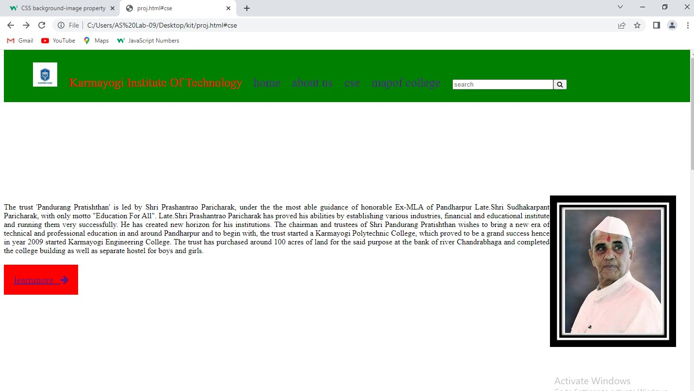

# After Clicking on About us-

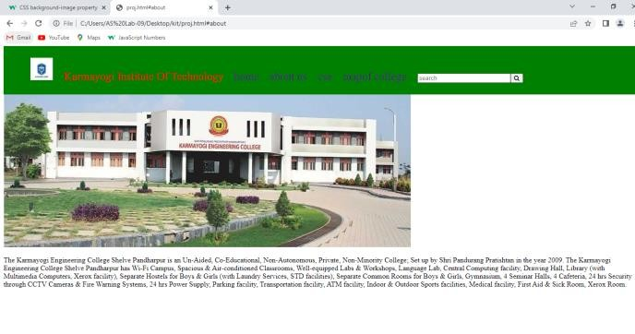 After Clicking on College Image- 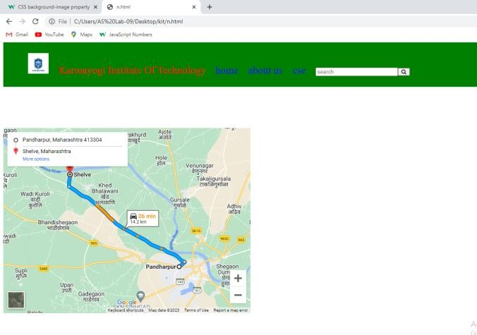After clicking on yellow button-

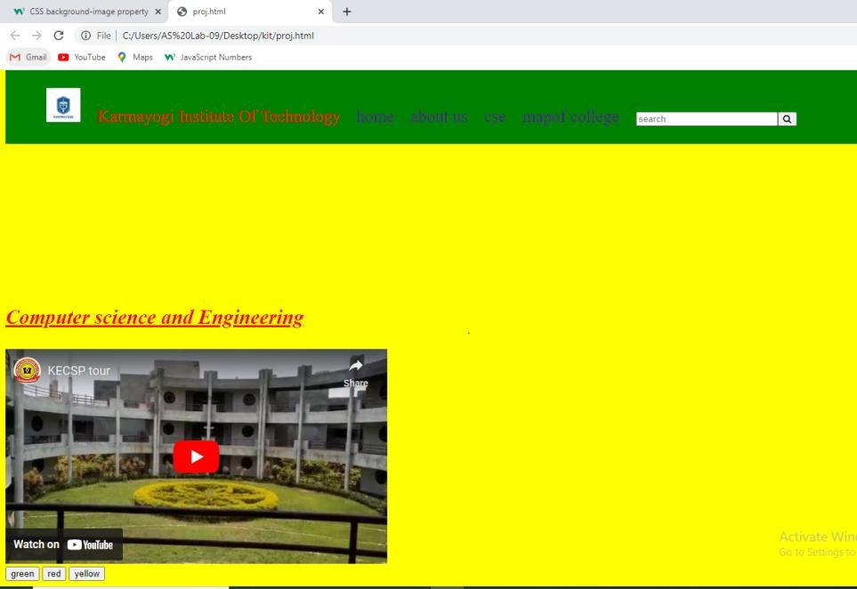

# Experiment No 4

<html>

<head>

<link rel="stylesheet" href="style.css">

<title>calculator</title>

</head>

<body>

<h1 style="text-align:center;">Calculator</h1>

<form>

<table align="center">

<tr>

<td colspan="4"><input type="text" name="display"></td>

</tr>

<tr>

<td><input type="button" value="1" onclick="display.value+='1'"></td>

<td><input type="button" value="2" onclick="display.value+='2'"></td>

<td><input type="button" value="3" onclick="display.value+='3'"></td>

<td><input type="button" value="+" onclick="display.value+='+'"></td>

</tr>

<tr>

<td><input type="button" value="4" onclick="display.value+='4'"></td>

<td><input type="button" value="5" onclick="display.value+='5'"></td>

<td><input type="button" value="6" onclick="display.value+='6'"></td>

<td><input type="button" value="-" onclick="display.value+='-'"></td>

<tr>

<td><input type="button" value="7" onclick="display.value+='7'"></td>

<td><input type="button" value="8" onclick="display.value+='8'"></td>

<td><input type="button" value="9" onclick="display.value+='9'"></td>

<td><input type="button" value="*" onclick="display.value+='*'"></td>

</tr>

<tr>

<td><input type="button" value="0" onclick="display.value+='0'"></td>

<td><input type="button" value="00" onclick="display.value+='00'"></td>

<td><input type="button" value="." onclick="display.value+='.'"></td>

<td><input type="button" value="/" onclick="display.value+='/'"></td>

</tr>

<tr>

<td><input type="button" value="%" onclick="display.value+='%'"></td>

<td><input type="button" value="AC" onclick="display.value=''"></td>

<td><input type="button" value="Del" onclick="display.value=display.value.slice(0,-1)"></td>

<td><input type="button" value="=" onclick="display.value=eval(display.value)"></td>

</tr>

</table>

</form>

</body>

</html>

# Output-

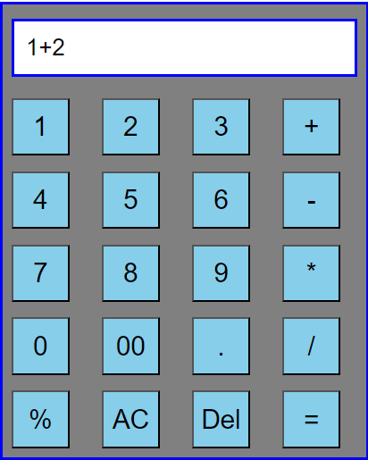

# Experiment No 5

# <html>

# <head>

# <title>User Form with Validation</title>

# <style>

# span {

# color: red;

# }

# </style>

# </head>

# <body>

# <form onsubmit="return fun()">

# <fieldset>

# <legend>Student Details</legend>

# <table>

# <tr>

# <td>Name:</td>

# <td><input type="text" name="name" id="uname" /></td>

# </tr> <tr>

# <td><span id="msg1"></span></td>

# </tr> <tr>

# <td>Mobile No:</td>

# <td><input type="text" name="mobno" id="mob" /></td>

# </tr> <tr>

# <td><span id="msg2"></span></td>

# </tr> <tr>

# <td>Email ID :</td>

# <td><input type="text" name="emailid" id="email" /></td>

# </tr> <tr>

# <td><span id="msg3"></span></td>

# </tr> <tr>

# <td></td>

# <td> <input type="submit" onclick="return fun()" value="Submit" /> </td>

# </tr>

# </table>

# </fieldset>

# </form>

# <script>

# function fun() {

# let valid = true;

# document.getElementById("msg1").innerHTML = "";

# document.getElementById("msg2").innerHTML = "";

# document.getElementById("msg3").innerHTML = "";

# var a = document.getElementById("uname").value;

# var b = document.getElementById("mob").value;

# var c = document.getElementById("email").value;

# if (a == "") {

# document.getElementById("msg1").innerHTML = "Enter NAME!";

# valid = false;

# }

# if (a.length < 3) {

# document.getElementById("msg1").innerHTML =

# "Enter NAME greater than 3 characters";

# valid = false;

# }

# if (a.length > 20) {

# document.getElementById("msg1").innerHTML =

# "Enter NAME less than 20 characters";

# valid = false;

# }

# if (isNaN(a) == false) {

# document.getElementById("msg1").innerHTML = "Enter NAME not Digit ";

# valid = false;

# }

# if (b == "") {

# document.getElementById("msg2").innerHTML = "Enter MOBILE NUMBER!";

# valid = false;

# }

# if (isNaN(b)) {

# document.getElementById("msg2").innerHTML =

# "Enter MOBILE NUMBER not Characters ";

# valid = false;

# }

# if (c == "") {

# document.getElementById("msg3").innerHTML = "Enter EMAIL ID !";

# valid = false;

# }

# var emailPattern = /^[A-Za-z0-9.]{3,}@[A-Za-z]{3,}[.]{1}[A-Za-z]{2,6}$/;

# if (emailPattern.test(c) == false) {

# document.getElementById("msg3").innerHTML = "Enter Valid EMAIL ID !";

# valid = false;

# }

# return valid;

# }

# </script>

# </body>

# </html>Output-

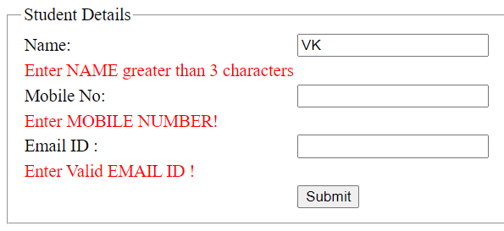

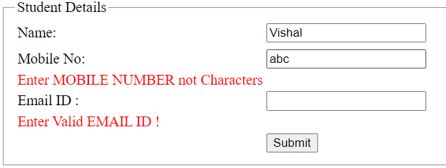

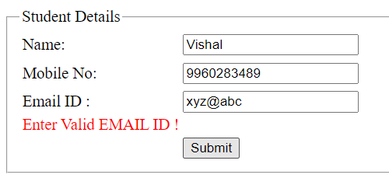

**Experiment no-6**

# Length of string

<html>

<body>

<p id="demo"></p>

<script>

let text = "hello";

let i = 0;

while ((text.charAt(i) != "")) {

i++;

}

document.getElementById("demo").innerHTML = i;

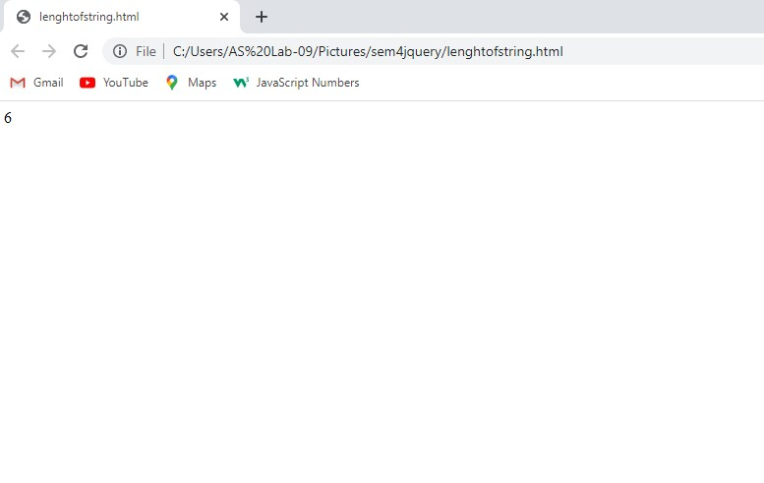 </script>

</body>

</html>

**Output-**

# Reverse String-

# <html>

# <head>

# <title>reverse a string</title>

# </head>

# <body>

# <p id="abc"></p>

# <script>

# let text = "helllo";

# let rev = "";

# for (let i = text.length; i >= 0; i--) {

# rev += text.charAt(i);

# }

# document.getElementById("abc").innerHTML = rev;

# </script>

# </body>

# </html>

**Output-**

# 

# Experiment No 7

# <html>

# <head>

# <title>list of prime number</title>

# </head>

# <body>

# <script>

# let start = parseInt(prompt("enter start num : "));

# let end = parseInt(prompt("enter end num : "));

# let isprime = true;

# for (let i = start; i <= end; i++) {

# if (i == 1) {

# i++;

# }

# for (let j = 2; j < i; j++) {

# if (i % j == 0) {

# isprime = false;

# break;

# }

# }

# if (isprime) {

# document.write(i + " ,");

# } else {

# isprime = true;

# }

# }

# </script>

# </body>

# </html>

# Output-

